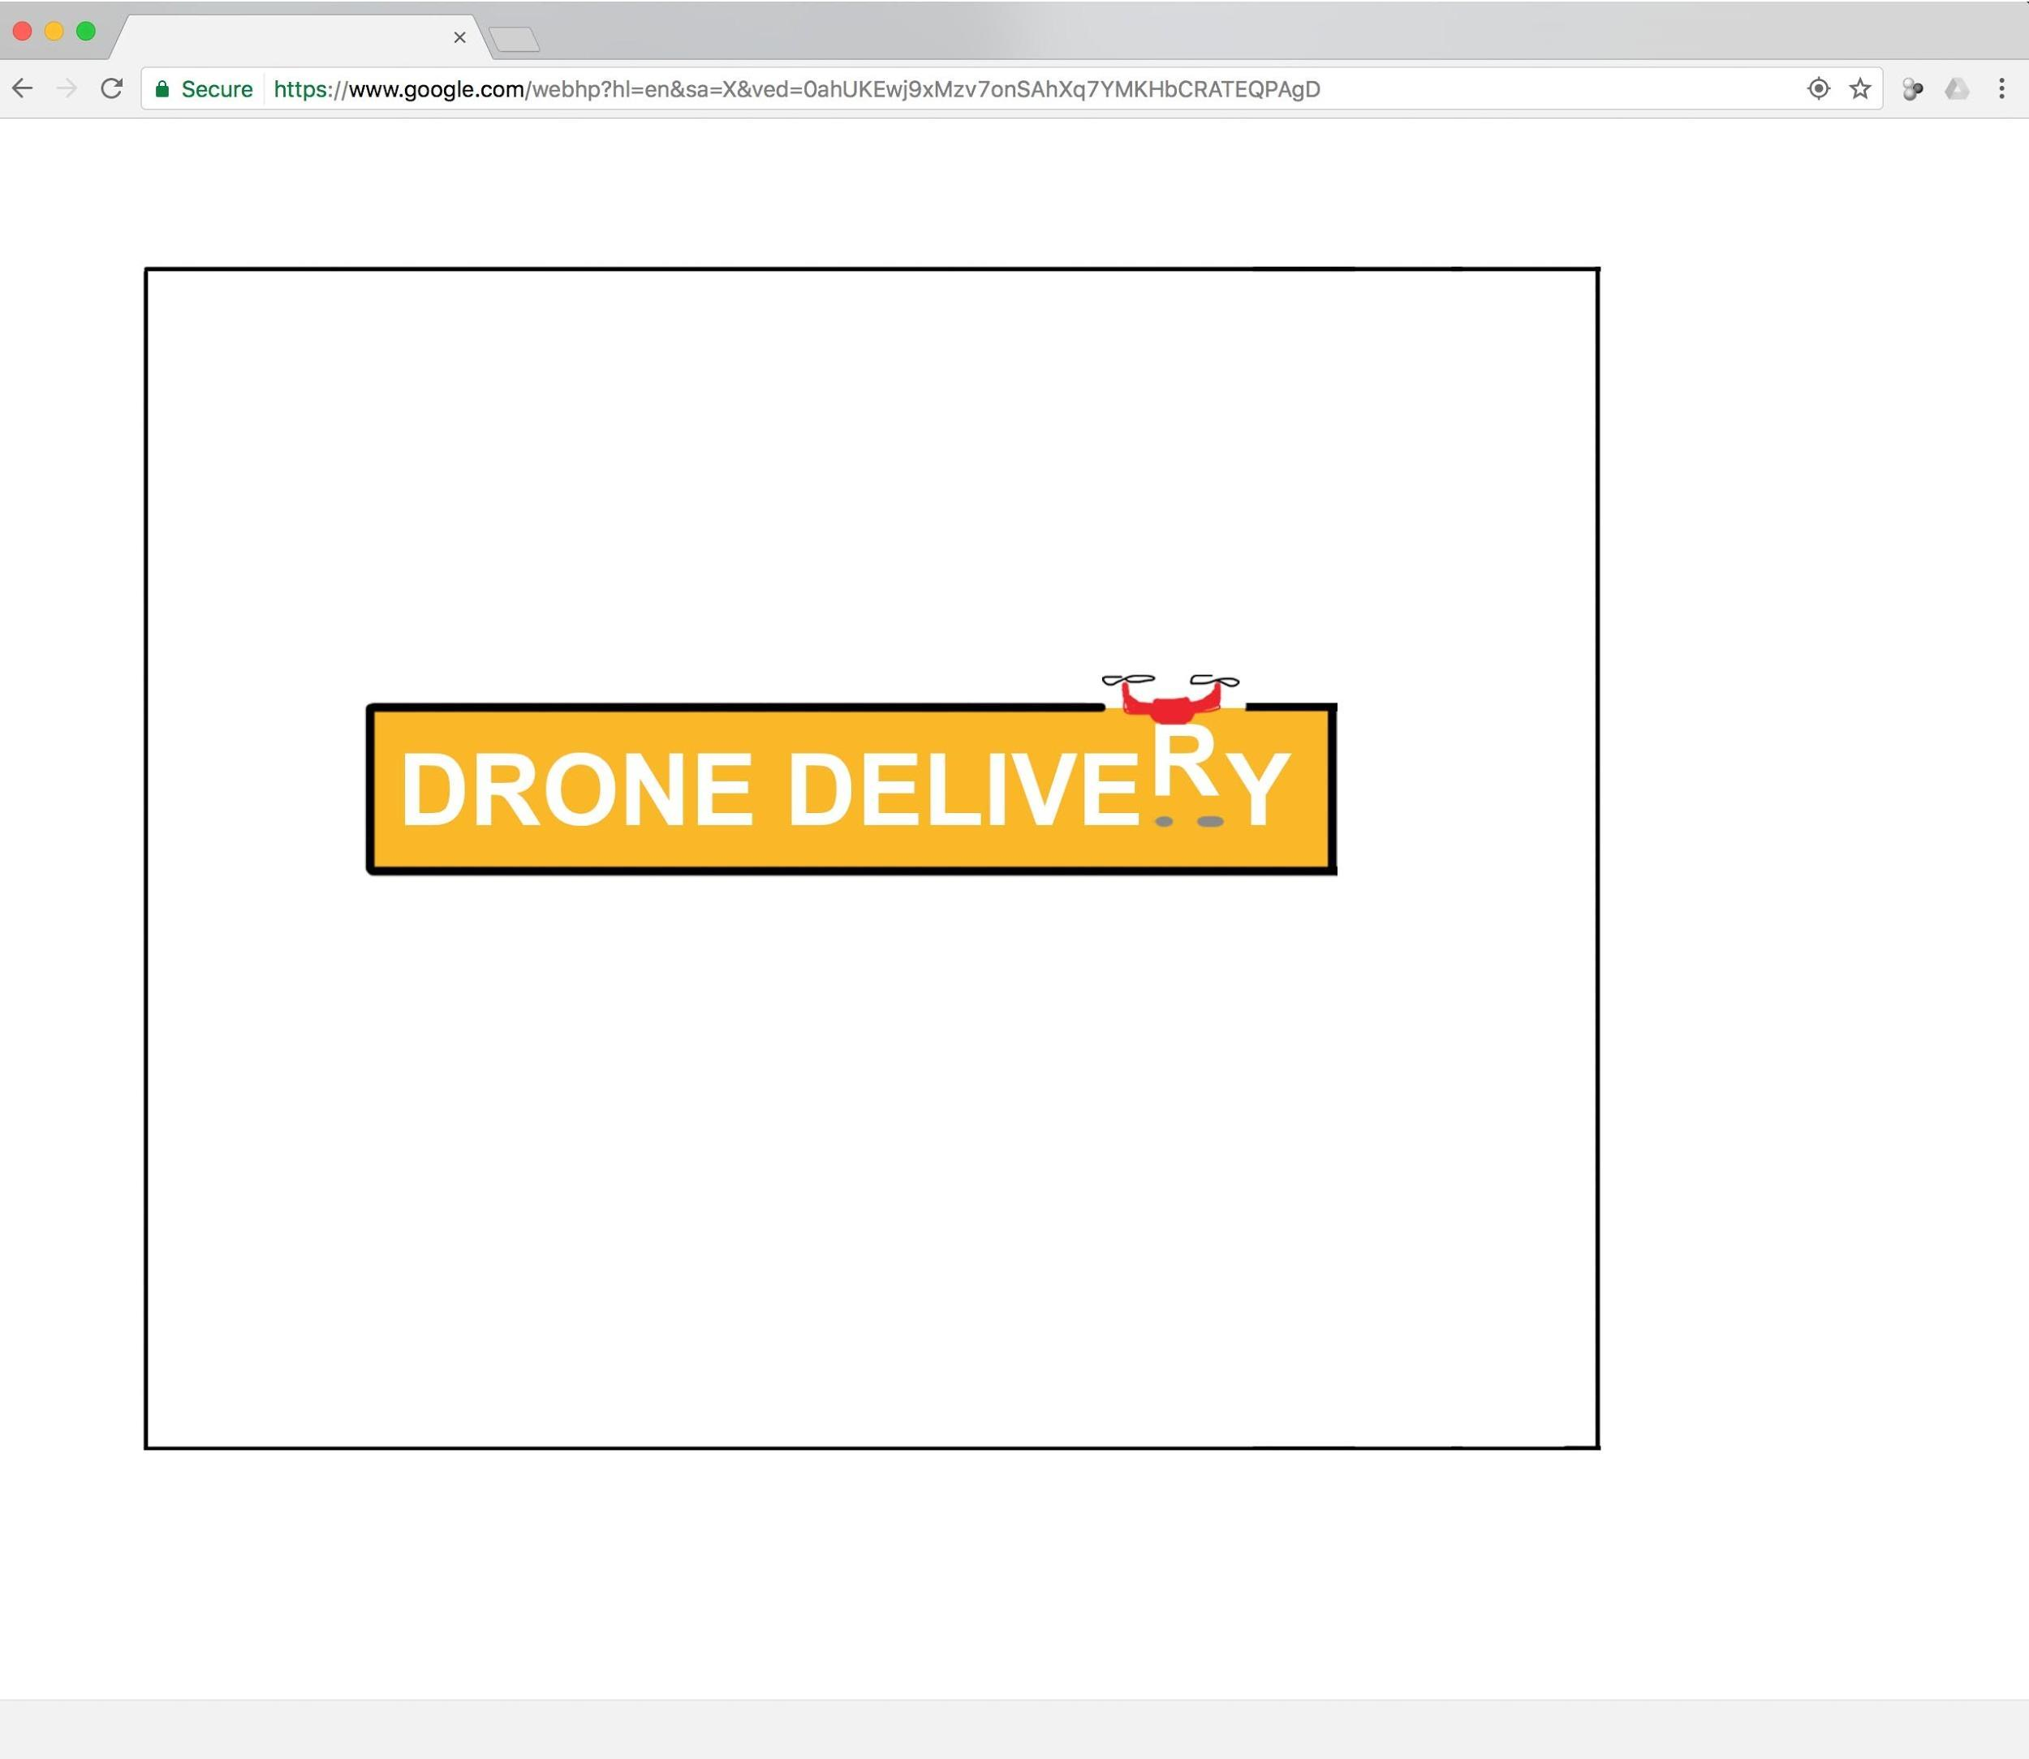

**Game Title**

Drone Delivery

**Project Goal**

Our goal is to develop the first full level of Drone Delivery.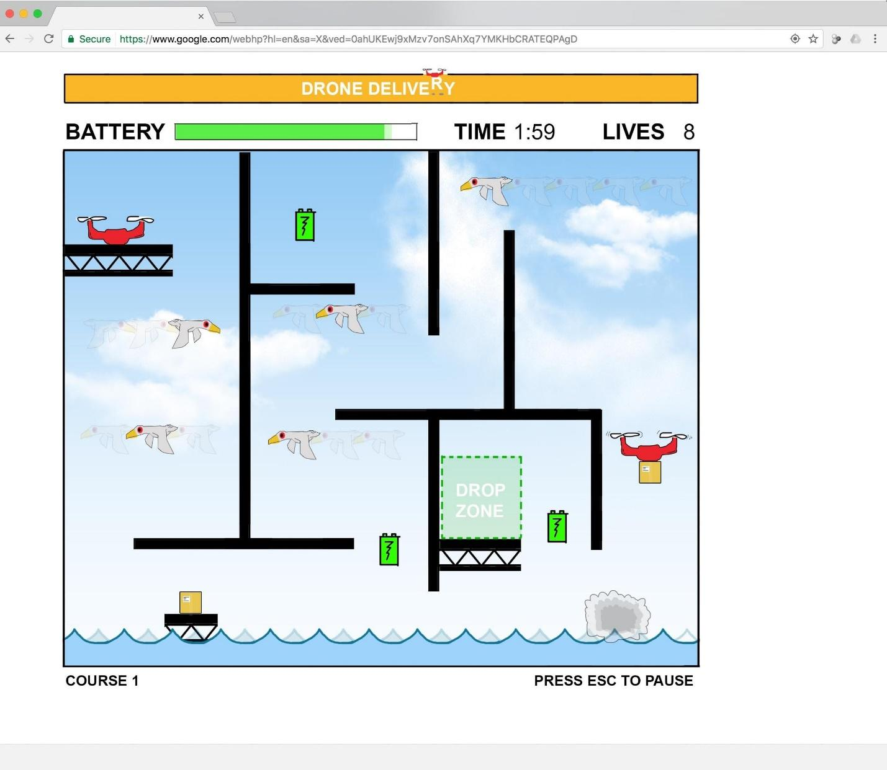

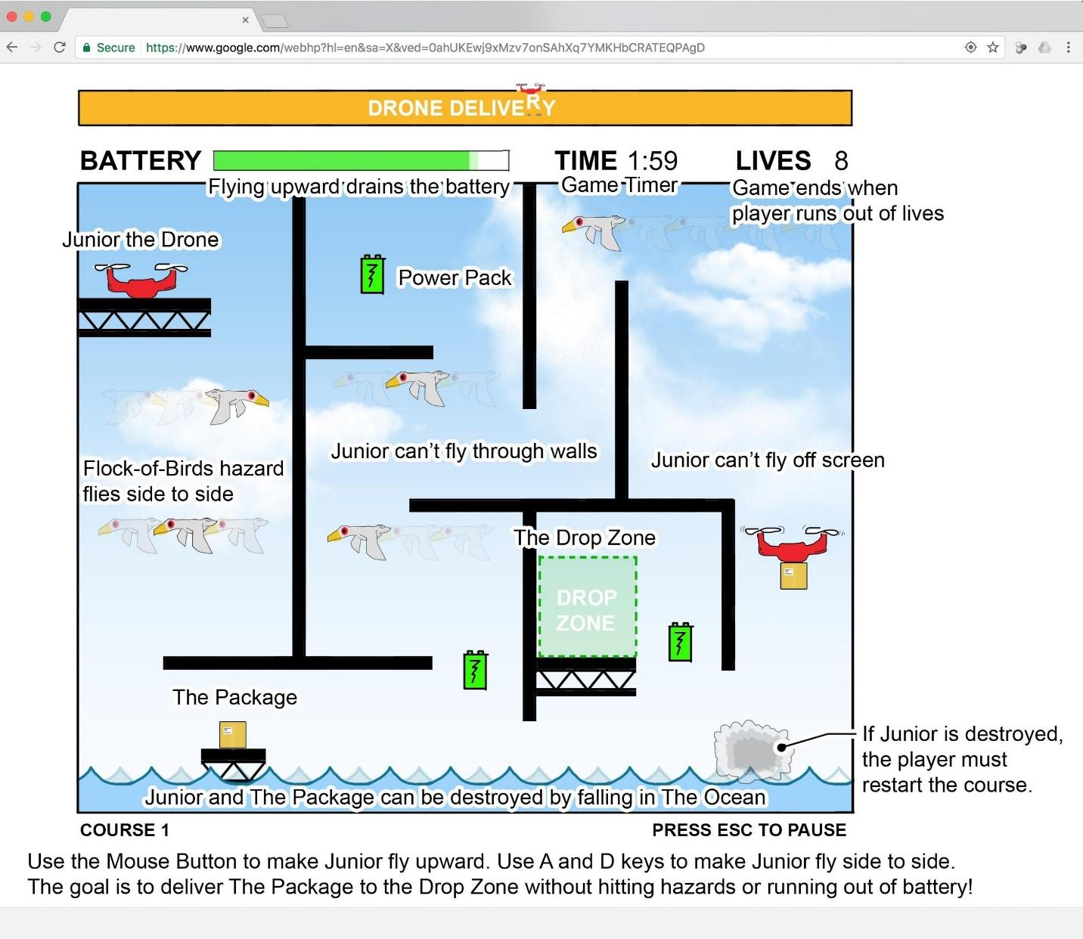

**Narrative**

It’s 2050 and delivering packages by Drone is all the rage! You have just enrolled in Drone Flying School to prepare for a career as a drone pilot. To successfully complete your training, you’ll need to guide Junior, your drone at hand, through a series of obstacle courses. Junior is powered using batteries and can be destroyed by touching hazards.

Each course will test your ability to navigate around these hazards, think critically, and deliver your package on time (with battery to spare!) Future courses may unlock opportunities to upgrade your drone and fly in style.

**Objective**

Junior the Drone must pick up and deliver The Package to the Drop Zone of each course, before time runs out on the Game Timer. Complete all courses to graduate from Drone Flying School as a pilot.

**Scene**

The game will be laid out as a single playing field, with the entire course visible. The background will be themed according to each particular course. Game title will be displayed outside and above this field. The top of the playing field window will contain the following game information:

* Time Remaining
* Lives Remaining
* Current Battery Life
* Level Number

By pressing ESC an in-screen popup box with the following options will be shown:

* “Press Spacebar to Begin New Game”

**Players**

Junior is a flying drone that players control on screen. He has twin engines and the ability to pick up certain objects. Junior will be positioned on a platform inside the course at the start of each attempt. He begins each course with a full battery, and requires battery power to fly.

**Game Objects**

Neutral objects include the following:

* The Package: each course will required that Junior pick up The Package and deliver it to the Drop Zone. If Junior drops or touches The Package to a hazard, The Package is destroyed and the player must start the level over.
* Power Packs: these objects are scattered throughout a course. Collecting a power pack recharges Junior’s battery life and allows him to fly for longer
* Drop Zone: this area is highlighted in each course. If Junior flies into the Drop Zone while carrying The Package, the course is successfully completed. Nothing occurs if Junior flies into the Drop Zone without The Package.
* Walls: create obstacles in the course which Junior must navigate around to succeed. Touching a wall won’t hurt you, but it sure won’t help you either.
* Ceiling: Junior can’t fly higher than the ceiling (top of game window). Touching the ceiling will not hurt Junior.
* Game Timer: limits the amount of time Junior has to deliver The Package

Hazards include the following:

* Flocks of Birds: these menacing creatures swoop side to side, and colliding with them will destroy your drone!
* The Ocean: the ‘floor’ of each course is flooded with water. If Junior touches the Ocean, he is destroyed

**Physics**

Environmental forces include the following:

* Gravity: if Junior doesn’t keep his engines going (mouse button down), he’ll start to fall out of the sky. If Junior drops The Package, it will fall out of the sky. Junior and The Package cannot be damaged by landing on a platform after falling.
* Battery Life: flying in the air reduces the level of remaining Battery Power. If Junior runs out of battery, he will drop from the sky. The speed at which Battery Life is reduced does not vary depending on whether Junior is carrying The Package or not.

**Events**

Things that trigger actions include the following:

* Human / user controls
  + Pressing spacebar during gameplay allows Junior to pick up The Package if Junior is in contact with the package. Pressing spacebar after holding The Package will release it.
  + Pressing and holding down the mouse button makes Junior fly higher
  + Releasing the mouse button lets Junior fall downward
  + A and D keys control movement left and right
  + Pressing ESC pauses the game and brings up the Game Menu. Pressing ESC again will close the game menu.
  + The user can use the mouse to select options from the Game Menu.
* Environmental Events
  + Each course will begin with all game objects exhibiting motion.
  + Each course begins with Game Timer paused. Flying upward will start the Game Timer.
  + Flocks-of -Birds will move side to side in timed intervals. Each Flock-of-Birds object in the course has its own interval, independent from the other Flocks of Birds.
  + Flying into the Drop Zone checks whether the course is completed or not. If Junior flies into the Drop Zone while carrying The Package, the course is successfully completed. Nothing occurs if Junior enters the zone without The Package.
  + If a player loses a life or completes a course, a popup will pause the game and notify the player of what occurred, requiring the press of spacebar to continue.

**Game Rules**

General:

* Junior must pick up and deliver The Package to the Drop Zone of each course in the game before the Game Timer runs out. The level is only considered completed if Junior enters the Drop Zone while carrying The Package. Nothing occurs if Junior enters the Drop Zone without The Package.
* Junior and The Package can be destroyed by colliding with Flock-of-Birds or by falling into the Ocean. Junior and The Package cannot be destroyed by contact with walls, platforms, or ceilings.

Losing a Life:

* If the Game Timer runs out before Junior delivers The Package, the player will lose a life and must start the course over.
* If Junior or The Package is destroyed, the player will lose a life and must start the course over.

End Game:

* If a player runs out of lives, the player is expelled from Drone Pilot School and must start the entire game over again.

**Platform**

Expected Equipment includes the following:

* Keyboard
* Computer Screen
* Mouse

**Assets**

Our game includes the following assets we have been learning about:

* Bitmaps: game background image
* Shapes: Junior the Drone, The Package, Flock-of-Birds, The Ocean, Drop Zone, Walls, Platforms
* Animation:
  + Flock-of-Birds objects will move side to side in intervals
  + Ocean will have visualization of water moving side to side
  + Junior the Drone’s propellers will be animated when he is moving upward
* Input: Keyboard and mouse will be used to control Junior and activate game features
* Containers: Lots of game objects can be grouped with containers. To name a few, the drone and its package or several birds into a flock of birds.
* Sprites: There are several game features that could utilize sprites including: the flocks of birds could have animated wing flaps using sprites and crashing Junior could result in an animated explosion.
* Sprite Animation: if Junior is destroyed, his Shape is replaced with a poof of smoke, which is an animated sprite.

**How Our Game Is Different or Unique**

Our game is a platform game, but most platforms have a player that moves along the ground (can’t fly). By making our drone fly, we’ve made possible a whole new set of challenges and scenarios, such as not being able to touch the ground or needing to navigate vertically as well as horizontally.

We’ve also added the ability to carry an object around and have that object interact with the world, which adds an extra dimension to gameplay. In this way, there are many more possibilities for interacting with the world. The Drone could lift objects and set them on switches or drop them on enemies.

Our game requires a combination of keyboard and mouse interaction to guide the Drone around the course. Rather than a simple D-Pad or only using the Mouse, players must use coordination to successfully navigate.

Finally, the theme of flying drones is new to 2D style games, and adds a modern flair!

**Credits / Backlog**

D: Drone P: Package O: Objects PP: Power pack GUI: GUI G: Gameplay

|  |  |  |  |  |
| --- | --- | --- | --- | --- |
| **Item** | **Phase** | **Type** | **Responsible** | **Completed?** |
| **Design course with wall, drop zone, flock-of-birds, ocean, platforms, The Package, and Drone, drop zone, hazard events functional, collision detection, movement controls functional for both package and Drone, ability to pause the game, add Container design** | **1** | **-** | **together** | **X** |
| Add ability for drone to pick up objects | 1 | D | Ryan | X |
| Add Collision Detection (drone) with game objects, game frame | 1 | D | Ryan | X |
| Add Drone movement controls | 1 | D | Ryan | X |
| Add interaction b/w drone and hazards | 1 | D | Jack |  |
| Add interaction b/w package and hazards | 1 | D | Jack |  |
| Animate Drone propellers | 1 | D | Ryan | X |
| Design Drone, add to game | 1 | D | Ryan | X |
| Add drop zone event | 1 | G | Jack | X |
| Add end-course event (Drone or Package hit hazard) | 1 | G | Jack |  |
| Add pause functionality | 1 | G | Ryan | X |
| Add background as bitmap | 1 | O | Ryan | X |
| Design container, add to game | 1 | O | Ryan | X |
| Design Drop Zone, add to game | 1 | O | Jack | X |
| Design Flock-of-Birds, add to game | 1 | O | Jack |  |
| Design Game background | 1 | O | Ryan | X |
| Design Ocean, add to game | 1 | O | Ryan | X |
| Design Wall and floor, add to game | 1 | O | Ryan | X |
| Add Collision Detection (Package) | 1 | P | Ryan | X |
| Add Package movement ability (independent of drone / dependent on drone) | 1 | P | Ryan | X |
| Design The Package, add to game | 1 | P | Ryan | X |
| Determine mechanics for how package relates to drone (move with drone, move independent of drone and can be dislodged) | 1 | P | Together | X |
| **Design course with battery effect on drone flying, powerpack event to add to battery power, animate Flock-of-Birds movement, ability to start new game from paused situation** | **2** | **-** | **together** |  |
| Add “new game” spacebar functionality to pause screen | 2 | G | Jack |  |
| Add battery level visualization | 2 | GUI | Ryan |  |
| Add in-game pause menu / text | 2 | GUI | Ryan |  |
| Animate Flock-Of-Birds (fly side to side) | 2 | O | Jack |  |
| Add battery level /draining feature to drone movement | 2 | PP | Ryan |  |
| Add power pack interaction event | 2 | PP | Jack |  |
| Design Power Pack, add to game | 2 | PP | Jack |  |
| **Design course with Game Timer, Lives functionality, sprites, end-course events of running out of time, running out of lives** | **3** | **-** | **together** |  |
| Add end-course event (timer runs out) | 3 | G | Jack |  |
| Add end-game event (run out of lives) | 3 | G | Jack |  |
| Add game timer functionality | 3 | G | Ryan |  |
| Add lives functionality | 3 | G | Jack |  |
| Add end-course/ end-game notification popup in-screen, pauses game after winning or being destroyed | 3 | GUI | Jack |  |
| Add game timer visualization | 3 | GUI | Ryan |  |
| Add lives visualization | 3 | GUI | Jack |  |
| Design Sprites, add to game | 3 | O | Jack |  |
| **Add course where all animations are implemented, start screen added, explanation of gameplay, course 1 is fully designed (all game objects in place)** | **4** | **-** | **together** |  |
| Add Tween animation of angling to start flying left or right | 4 | D |  |  |
| Add Tween animations of bounce-back after hitting neutral game object | 4 | D |  |  |
| Improve Drone propellor design and animation | 4 | D | Ryan |  |
| Add explanation of gameplay / goal at beginning of game | 4 | GUI |  |  |
| Add Game Start Screen | 4 | GUI | Ryan |  |
| Add level number visualization | 4 | GUI |  |  |
| Add paused game text at beginning of each course | 4 | GUI | Jack |  |
| Add Sprite animation to game | 4 | O |  |  |
| Animate Ocean (water movement / waves) | 4 | O | Ryan |  |
| Design Sprite animation | 4 | O |  |  |
| **Present finished Course 1 with all features** | **5** | **-** | **Together** |  |